**Ansible Installation**

**Step 1:** Please ensure Operating version is up to date, using below yellow command update the version

**yum update**

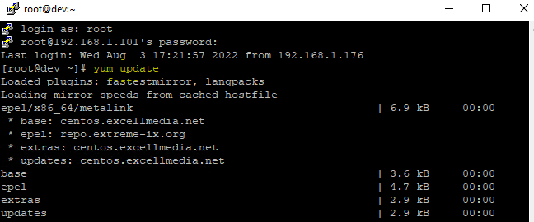

Figure 1 Execute yum update command

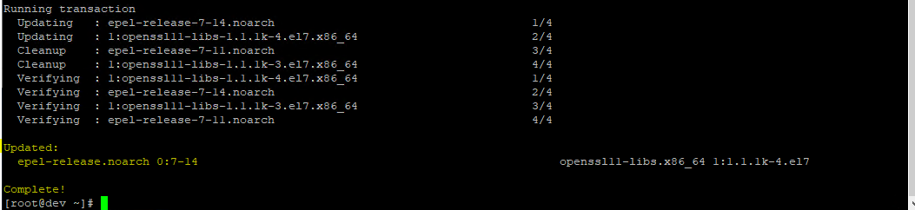

Figure 2- yum update command completed

**Step 2:** Install EPEL Repository to install commonly used packages on CentOS.

**yum install epel-release**

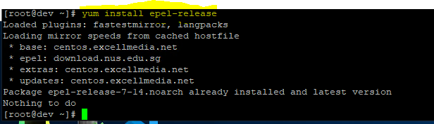

Figure 3-Install the EPEL repository on the system.

**Step 3:** Install the Ansible package from the EPEL repository.

**yum install ansible**

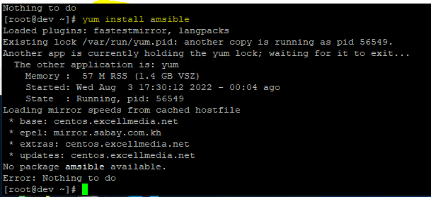

Figure 4- Install ansible package

**Step 4:** Create a User for Ansible

Add a user and set a password onto your Controller node.

**useradd sample**

**passwd sample**

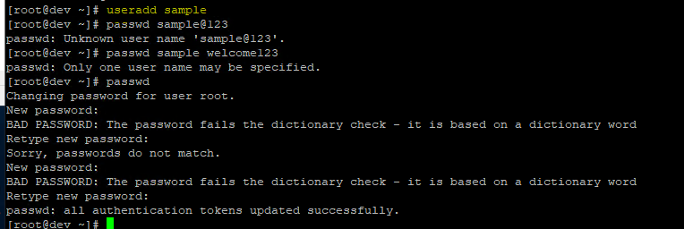

Figure 5-Add user and set the password

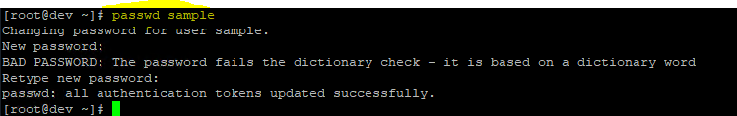

**Step 5:** Configure Our Admin User for SSH Access

**ssh-keygen**

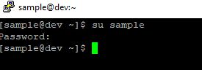

Configure Our Admin User for SSH Access

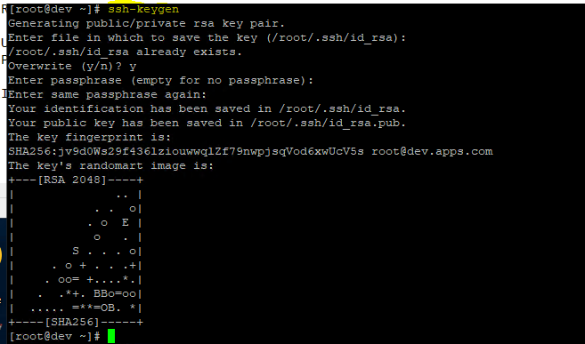

copy the public key and paste it to our Managed node with the command below. ssh-copy-id node.kb.liquidweb.com

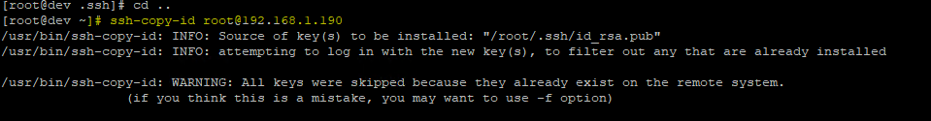

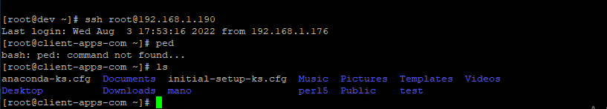

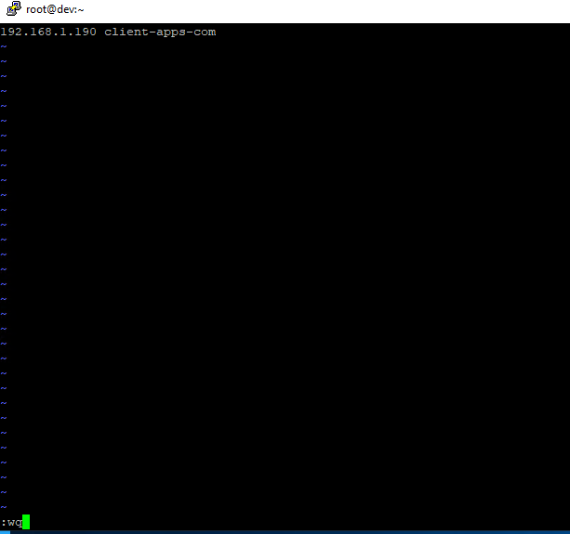

**Step 6:** Create an Inventory

vim /home/admin/inventory

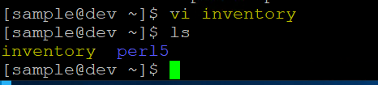

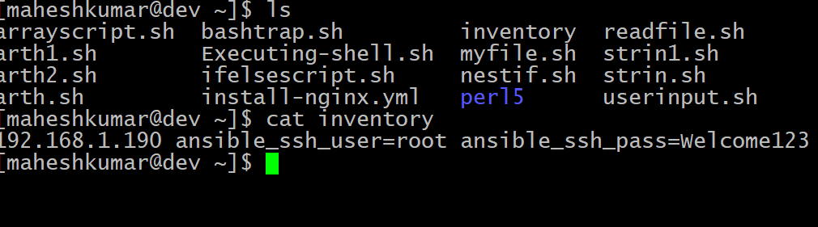

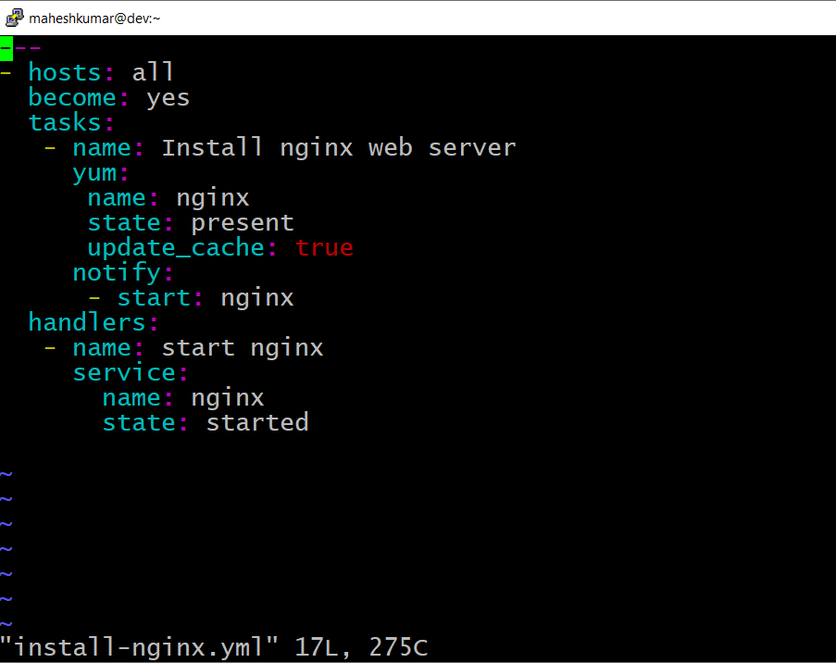

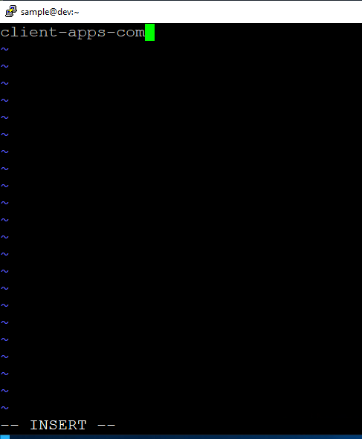

**Step 7:** Create an Ansible Playbook

vim /home/simplilearn/install-nginx.yml

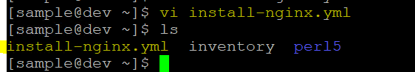

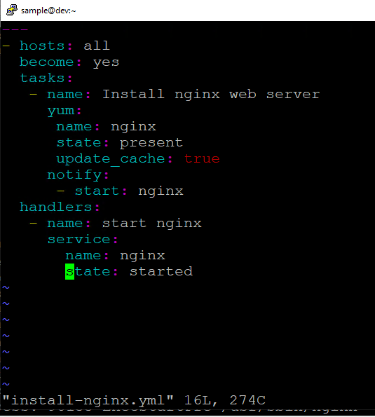

**Step 8:** Run the Playbook

**ansible-playbook -i /home/admin/inventory /home/admin/install-nginx.yml**

